We are pleased to welcome Dr J Kallarakel who joined us on the 1st April 2021.

“I qualified in 1995 and initially trained as a paediatrician. I started my career in General practice in 2002. I have been a Gp Partner for sixteen years in East Lancashire before moving to Shropshire. My special interests are Paediatrics, Diabetes, Palliative care and Minor Surgery including joint injections.”
Claremont Bank Surgery Newsletter
July- October

COVID RESTRICTION UPDATE
Throughout the pandemic we have strived to make the surgery as safe as possible for all our patients and staff. We will continue to do so going forward.
From the 19th July nothing will change at the surgery. Patients will need to still wear a mask, socially distance and use hand sanitiser and staff will continue to wear PPE. We do understand that it can be frustrating but we know that when people come to see us they are sick and vulnerable (and some cannot receive the Covid vaccinations due to medical reasons) so we feel it would be wrong to not take these small precautions that can protect people.
In terms of opening up, as many of you know, we have never been shut and in fact have consulted with much higher numbers of patients than we did pre-covid (face to face, by the phone, be eConsult and by video), not counting vaccinating 90% of the adult population twice in the last 6months.
The local community has come so far trying to minimise the impact of Covid and we are sure you understand that we need to keep the surgery as safe for ALL patients as we can.

Supporting armed forces personnel and their families
As a CCG, we are committed to ensuring that those who have served in the armed forces, veterans, reservists and their families living in our county have the right access to services to help support their health and wellbeing needs.
To demonstrate our absolute commitment to this, we are asking GP practices across Shropshire, Telford and Wrekin to sign up to the Armed Forces Covenant.
The Armed Forces Covenant sets out a number of health commitments for the armed forces community:
- The armed forces community should enjoy the same standard of, and access to healthcare as that received by any other UK citizen in the area they live.
- Family members should retain their place on any NHS waiting list, if moved around the UK due to the service person being posted.
- Veterans should receive priority treatment for a condition which relates to their service, subject to clinical need.
- Those injured in service should be cared for in a way which reflects the nation’s moral obligation to them, by healthcare professionals who have an understanding of the Armed Forces culture.
To find out more, visit www.armedforcescovenant.gov.uk or to sign up to the covenant to show your support, visit https://www.armedforcescovenant.gov.uk/get-involved/sign-the-covenant/

Physical health checks for people with severe mental illness

People living with severe mental illness (SMI) face one of the greatest health inequality gaps in England.
The life expectancy for people with SMI is 15-20 years lower than the general population and is thus a clinical priority identified in The NHS Long Term Plan.
The COVID pandemic has put extreme pressures on primary care and whilst practices have endeavoured to undertake SMI physical health checks, in Shropshire, Telford and Wrekin for 2020-21 only 24% of those on SMI registers received a physical health check with the six key elements completed. The national target is to reach above 60%.
For support, practices can contact the MPFT Nurse Practitioners who are available to work alongside GP practice staff and can provide advice and consultation on the appropriate interventions including;
- advice and guidance regarding medication issues relating to mental health and
- Supporting access to mental health treatment or signposting for further intervention.
"This practice is supporting vital health and care planning and research by sharing your data with NHS Digital. For more information about this see the GP Practice Privacy Notice for General Practice Data for Planning and Research."
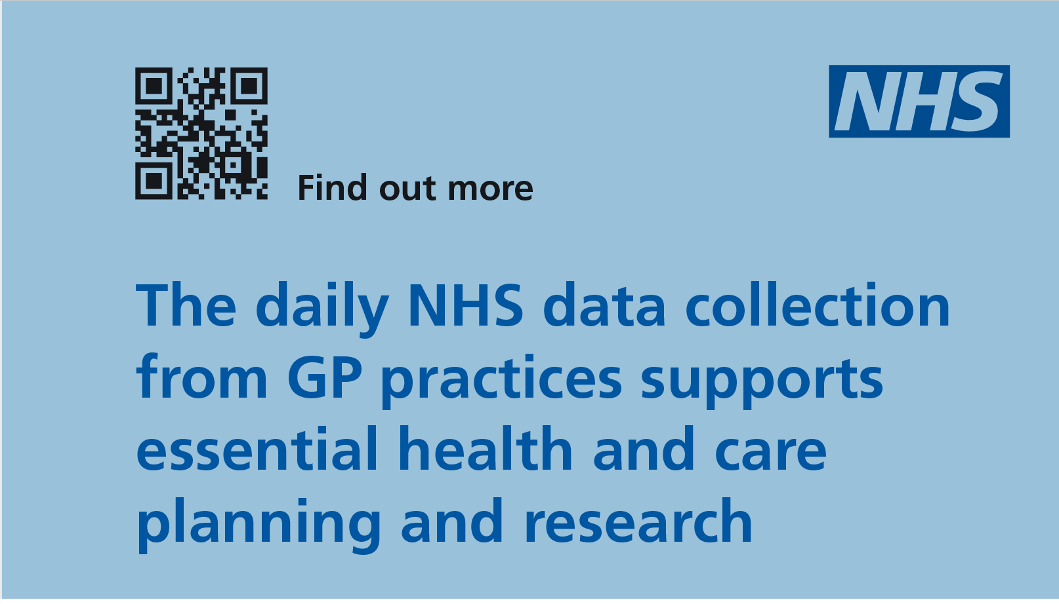

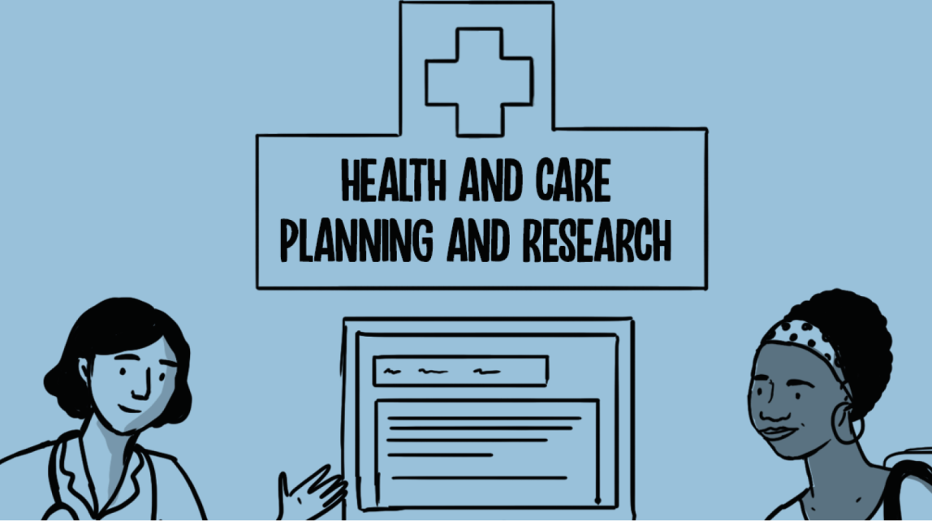
[Type a quote from the document or the summary of an interesting point. You can position the text box anywhere in the document. Use the Drawing Tools tab to change the formatting of the pull quote text box.]
[Type a quote from the document or the summary of an interesting point. You can position the text box anywhere in the document. Use the Drawing Tools tab to change the formatting of the pull quote text box.]
[Type a quote from the document or the summary of an interesting point. You can position the text box anywhere in the document. Use the Drawing Tools tab to change the formatting of the pull quote text box.]

CYCLE TO WORK DAY THURSDAY 5TH AUGUST 2021

10TH SEPTEMBER 2021

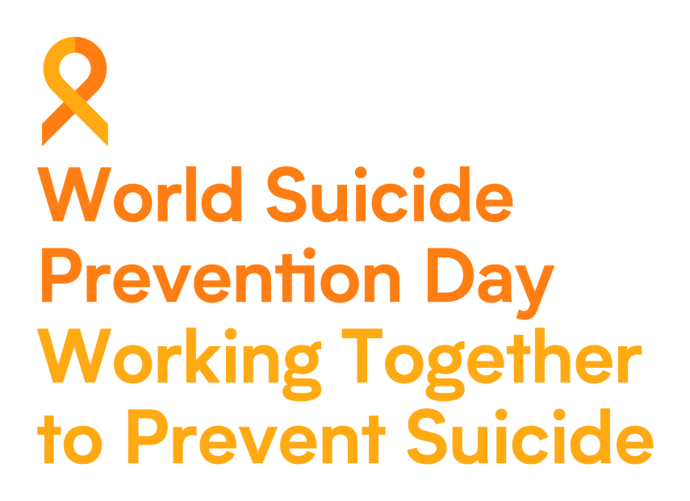

Good Care Month July 2021
With both ageing population and individuals of all ages with more complex needs that require additional social care support, there is an increasing requirement to recruit and retain staff in the adult social care sector.

We are pleased to welcome our new practice nurse Michelle

“I have been a Practice Nurse for 8 years and have a special interest in Diabetes. In the next year I hope to complete a 'Lifestyle Medicines' Course and am interested in learning how our patients can benefit from this. I have recently taken up Stand up Paddle boarding so I love being at Claremont because it's close to the river!”

We are sorry to see our Practice Nurse Suzanne leave after 9 great years with us. Suzanne will be sorely missed by her colleagues and patients a like but we wish her the very best in her future ventures.

Deafblind Awareness Week 2021

June 27 - July 3

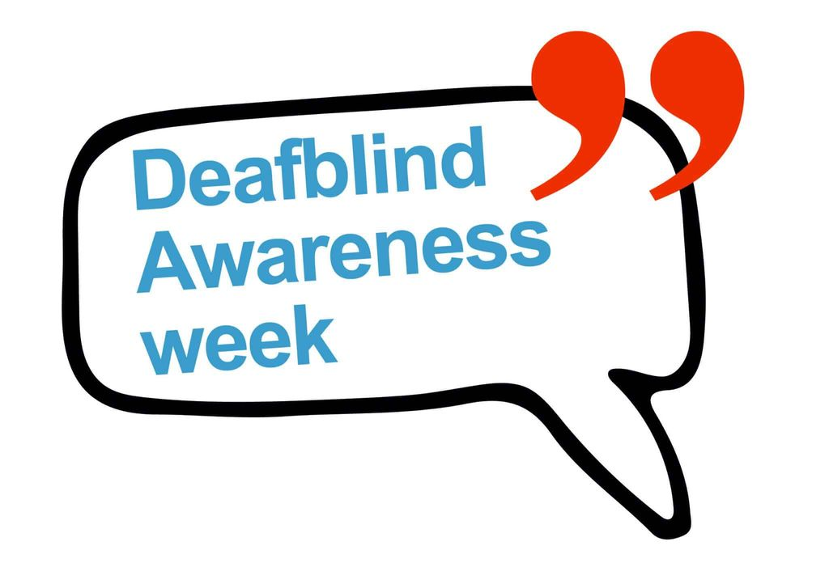

Dr Mary Eardley will be leaving us on 13th August 2021, after 16 years at Claremont Bank Surgery. She is moving to work as a salaried GP in South Shropshire and will also help to deliver the Covid vaccination programme. Dr Eardley would like to thank you for all the support and good wishes that she has received, and will miss Claremont Bank patients very much.

Talk To Us 2021

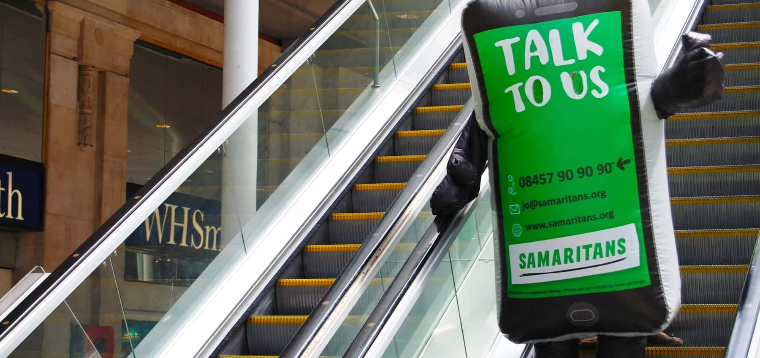

July 1 - July 30
Talk to Us is the Samaritans annual awareness-raising campaign.
Samaritans are challenging the UK to become better listeners by sharing expert tips on how to be a better listener. Throughout July, Samaritans branches are also holding events throughout the UK and Ireland to raise awareness of the services they offer in their local communities. Visit your local branch website to see what they’re doing during Talk to Us.

FRIENDS AND FAMILY APRIL- JUNE 2021

